 |  | 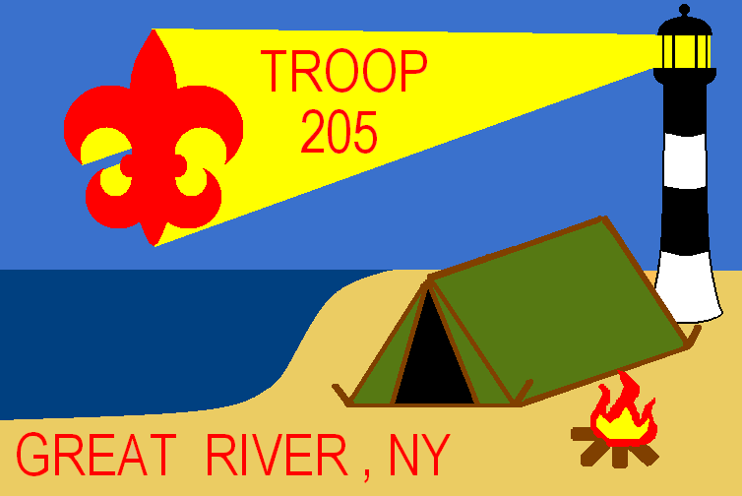
____________________________ Patrol

Saturday Breakfast |  | Saturday Lunch |  | Saturday Dinner |  | Sunday Breakfast
Preparation |  | Preparation |  | Preparation |  | Preparation
Cooking |  | Cooking |  | Cooking |  | Cooking
Cleaning |  | Cleaning |  | Cleaning |  | Cleaning
Patrol Leader: ________________________________________
Asst. Patrol Leader: _________________________________________________________

