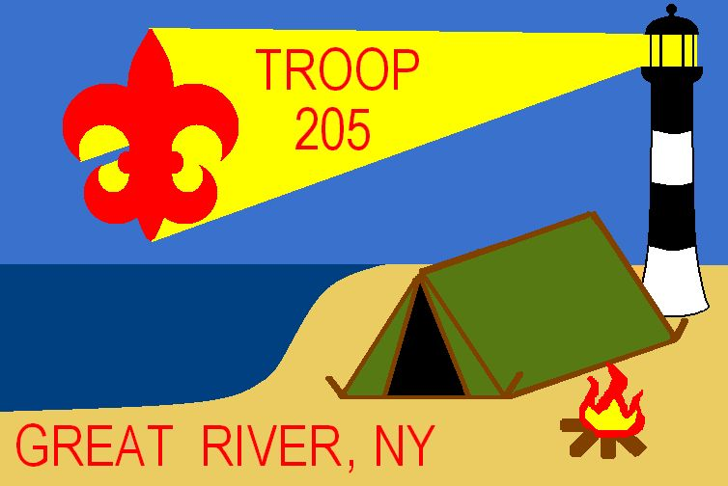

Troop 205 Travel Protocol
Troop 205 prides itself on promoting and maintaining a safe environment for all of its activities. This practice includes the trips we take to and from the activities. The following protocol is for use whenever there is more than one vehicle driving, so that the group will travel in an organized and safe manner.
- All travel will be in accordance with the BSA’s Guide to Safe Scouting under the following sections: “Leadership Requirements for Trips and Outings” subparagraph 2, and “Transportation/Automobiles”
  - These sections detail who can drive, speeds, use of seatbelts, and establishment of pre-planned meeting places checkpoints and rest stops
  - The BSA guide also stresses to not drive in a convoy and to avoid driver fatigue
- In accordance with the Guide to Safe Scouting, one leader is assigned as the Tour Leader. This leader will, in addition, be designated as the leader for the drive or if required, the Tour Leader can designate an alternate leader for coordinating the driving to and from the destination.
- Before the trip begins, the plan for the trip from beginning to end will be reviewed by the leader and all the adults, so all adults understand the trip plan prior to departing
  - For trips which are longer than 3 hours a designated checkpoint will be established approximately 2 hours into the trip. This is to avoid driver fatigue and allow the group to catch up
  - For trips which are less than 3 hours, all cars will meet at the destination prior to checking in with the camp and proceeding to the camp site
  - Any driver may request to stop at any time
  - If a driver needs to make an emergency stop, bathroom, etc., the leader must be informed so that, if necessary, arrangements can be made for an additional checkpoint stop
  - Final meeting place will be at the destination where all will be accounted for prior to check-in with the camp and heading out to the camp site
- Within each car, there is to be a list of the cell phones to reach each of the other cars. To avoid having a driver distracted by talking on the phone, there should be a number for an alternate adult within the car or there should be an alternate person who can access the cell phone. A list of numbers will be provided prior to departure. All cell phones must be turned on.
- Each adult should have a roster of those in attendance with the emergency contact information provided.
- Both phone lists (if different) will be provided to at least one “at-home” person.
- Driving directions, maps, and any other pertinent information will be distributed by the leader prior to departure.
- Any change from the planned trip, whether arranged beforehand or during the trip, must be communicated with and approved by the leader.
- As a rule the unit travels as a unit. That means unless otherwise approved by the leader, the troop will meet get organized and depart together. If established, they will meet at the designated checkpoint, otherwise meet at the destination and wait for all to arrive before proceeding to the camp site. It does not mean cars drive in a convoy.
  - All registered members of the Troop travel in uniform.
  - Upon departing from the campsite to return home, no car can leave without first getting the clearance from the tour leader and a head count is performed.
- Having an EZ Pass is strongly encouraged.
- All drivers should have their vehicles “topped off” with gas before meeting the Troop for departure and have their vehicle in good mechanical and safe working order.

